

ASSET VERIFICATION AND RECORDING TOOL KIT


Plot 31, Bukoto Street
P.O Box 7657, Kampala, Uganda
+256 (0) 39 2000216/0772525235
email: cpa@cpa.ug

www.cpa.com

August to September 2026

VERIFICATION DETAILS

NAME OF THE REGION: | EASTERN REGION
SUB-REGION: | BUSOGA
Name of Local Government | BUGWERI DISTRICT LOCAL GOVERNMENT
VERIFIER PARTICULARS
Full name | KIYUBA SALIMU
Contact/ email and Telephone | 0755215778, kiyubasalimu@gmail.com
Supervisor/ Sub team leader | NANDUDU SULAINA
Name | WANDERA SOLOMON
Contact | 0708153235
Date of submission

HEALTH CENTRES
INFORMANT INTERVIEW/DISCUSSION GUIDE (INCHARGE OR RESPONSIBLE PERSON)

Name of Health Centre: NAWANGISA HEALTH CENTRE III

1a | Does the Facility have a record of all assets provided under UgIFT.  (Obtain a record and verify if it has the costs and numbers supplied | No
1b | If Not ask how many were supplied and when.

2 | How does this facility Maintain (repair/service/replace) the assets provided under Ugift  - Minor maintenance such as cleaning, servicing, simple repairs and replacement of basic parts is done by the facility staff of NAWANGISA itself(In Charge)

3 | Does the facility take regular record about functionality/ or breakdown of the assets provided? | - YES  - they have an inventory book where they record the break downs

4 | How has the UgIFT support helped in service delivery in the area, any issues, challenges and any recommendations for better program implementation. | HOW UGIGT HAS SUPPORTED IN SERVICE DELIVERY  - It has improved the quality of health service delivery at Nawangisa sub county because most of the admissions e.g maternity  - It has motivated health workers through better accommodation and working environment  - It has increased the capacity of the facility to handle more patients at once i.e they can handle pediatrics, adults and pregnant mothers  - It has also improved infection prevention and control through provision of sterilization trays and trolleys  CHALLENGES  - The facility has limited space for safe storage of newly supplied equipment and furniture. This causes congestion  - Inadequate staff. The staff at the facility is not enough to handle the high number of patients at Nawangisa health centre iii.  - maintenance and repair. Maintenance of sophisticated equipment takes too long. After reporting ti the district, it takes weeks or months for the regional workshop team  - Limited solar power capacity.the facility uses solar power but the solar system is limited and can not run all the heavy equipment at the same time. During rainy,cloudy days, and at night, the power battery becomes low and some equipment can not work effectively.  RECOMMENDATIONS  - Consider deploying more staff at Nawangisa Health center iii.  - Strengthening maintenance system. A clear and faster maintenance response system should be put on place. The district should have a direct contact person and the regional workshop should do a regular preventive maintenance regular visit to the facility not only when the equipment breakdown.

PROCEED TO VERIFICATION AFTER THIS DISCUSSION

Health centre checklist

NAME OF LG : BUGWERI DISTEICT
NAME OF HEALTH FACILITY : NAWANGISA HC III

Equipment/ Item | Department | Asset Number | Item  Description | Life in Months | Tag Number ( engrave no.) | Date Of Purchase | Date Placed In Service | Recoverable cost | Cost | Acc Dep Cost | Net Book Value | Ytd Deprn | Equipment status | Remarks
B.P. Machine, Digital | health |  | It is white in color model 2088C with a black surface and a rectangular screen |  | Not Engraved |  | 29/03/2023 |  | 672,000 |  |  |  | functioning | 2 received, verified and in use
B.P. Machine (Aneroid wall mounted) | health |  | It has a gauge, white in color, with a black metallic base mounted on the wall |  | Not Engraved |  | 29/03/2023 |  | 672,000 |  |  |  | Good and functional. | 2 received, verified and in use
Bowl, Kick | health |  | Standard silver steel medical bowl with mobile kick stand. |  | Not engraved |  | 29/03/2023 |  |  |  |  |  | Good and functional | 1 received, verified and in use
Bowl Stand | health |  | Standard double bowl size with 2 bowls |  | Not engraved |  | 29/03/2023 |  | 280,000 |  |  |  | Good and functional | 2 received, verified and in use
Counting chamber Neubauer- Improved | health |  | It’s a clear glass improved device with silver etched grid and 2 transparent covers slips in blue plastic case. |  | Not engraved |  | 29/03/2023 |  | 336,000 |  |  |  |  | 2 received, verified and in use
Cupboard Steel, Lockable | health |  | Standard grey metallic steel cupboard with lockable double door and adjustable shelves. |  | Not engraved |  | 29/03/2023 |  | 2,016,000 |  |  |  | Good and functional | 2 received, verified and in use
Drip Stand | health |  | It is a Grey metallic drip stand with adjustable heights, 4 hooks on top with 5 castor wheels for mobility. |  | Not engraved |  | 29/03/2023 |  | 1,600,000 |  |  |  | Good and functional | 8 received but in store. They have others to use
ESR Stand | health |  | A standard metallic grey metal with adjustable leveling for holding tubes. |  | Not engraved |  | 29/03/2023 |  | 280,000 |  |  |  | Good and functional | 1 received, verified and in use
Examination Couch | health |  | A standard grey metallic frame table with black mattress on top, adjustable with a handle. |  | Not engraved |  | 29/03/2023 |  | 1,568,000 |  |  |  | Good and functional | 2 received, verified and in use
Examination light,LED | health |  | A metallic stand light with bright white led light, adjustable head used for examining patients |  | Not engraved |  | 29/03/2023 |  | 1,904,000 |  |  |  | Good and functional | 2 received, verified and in use
Glucometer | health |  | A small black portable machine with screen and test strips . |  | Not engraved |  | 29/03/2023 |  | 448,000 |  |  |  | Good and functional | 2 received but 1 in use
Haemoglobin Meter, Digital | health |  | A small portable handheld device, white and grey plastic with screen on top. |  | Not engraved |  | 29/03/2023 |  | 4,000,000 |  |  |  | Good and functional | 1 received, verified and in use
Height Meter | health |  | A tall vertical metallic stand, silver in color with flat base and sliding head and height scale. |  | Not engrave |  | 29/03/2023 |  | 896,000 |  |  |  | Good and functional | 1 received, verified and in use
Instrument Trolley | health |  | Medium sized, Grey in color with 2 compartments , the lower one bigger than the upper one |  | Not engraved |  | 29/03/2023 |  | 1,900,000 |  |  |  | Good and functional | 2 received, verified and in use
Microscope Binocular |  |  | A black and grey metallic device with double eye pieces on top, round base, lenses, knob. |  | Not engraved |  | 29/03/2023 |  |  |  |  |  | Good and functional | 1 received, verified and in use
Otoscope | health |  | A small handheld black plastic device, torch like shape with light head on top and pocket sized. |  | Not engraved |  | 29/03/2023 |  | 392,000 |  |  |  | Good and functional | 1 received, verified and in use
Patient Screen | health |  | A metallic folding frame, blue cloth, 3- panel, stands on 4 wheels. |  | Not engraved |  | 29/03/2023 |  | 2,016,090 |  |  |  | Good and functional | 4 received, verified and in use
Patient Trolley | health |  | A rectangular stainless steel frame, silver metallic with 2 selves, 4 wheels with 2 lockable, medium sizes with a push handle. |  | Not engraved |  | 29/03/2023 |  | 2,240,000 |  |  |  | Good and functional | 1 received, verified and in use
Refrigerator, Basic | Health |  | Medium size upright electric device, grey metallic outer body with single door and selves. |  | Not engraved |  | 29/03/2023 |  | 2,240,000 |  |  |  | Good and functional | 1 received, verified and in use
Stethoscope | Health |  | Black in color with 2 rubber flexible tube |  | Not engraved |  | 29/03/2023 |  | 1,568,000 |  |  |  | Good and functional | 4 received, verified and in use
Stop Watch | health |  | Handheld digital timer with start, stop and reset function. |  | Not engraved |  | 29/03/2023 |  | 448,000 |  |  |  | Good and functional | 2 received, verified and in use
Stretcher | Health |  | It’s a bed with 4 black wheels ,two rails and black soft sponge |  | Not engraved |  | 29/03/2023 |  | 2,240,000 |  |  |  | Good and functional | 1 received, verified and in use
Stove, Gas | health |  | It’s a burner gas with a gas cylinder and regulator. |  | Not engraved |  | 29/03/2023 |  | 504,000 |  |  |  | Good and functional | 1 received, verified and in use
Weighing Scale with Height Meter, Adult | health |  | Tall, White in color, automated with a height and a gauge. With a black rectangular base in nature |  | Not engraved |  | 29/03/2023 |  | 3,000,000 |  |  |  | Good and functional | 2 received, verified and in use
Weighing Scale, Infant |  |  | It’s a digital scale with a small white plastic tray |  | Not engraved |  | 29/03/2023 |  | 1,456,000 |  |  |  | Good and functional | 2 received, verified and in use
Weighing Scale, Toddler | health |  | A standard white and light blue electronic device with a large tray, LCD display, height rod. |  | Not engraved |  | 29/03/2023 |  | 490,000 |  |  |  | Good and functional | 2
Medical Waste Bin | health |  | Medium 20litre, plastic bin with a footpad. |  | Not engraved |  | 29/03/2023 |  | 1,209,600 |  |  |  | Good and functional | 6 received, verified and in use
Wall Clock | health |  | A round white dial device, black numbers and hands, plastic body with glass cover and wall hanging. |  | Not engraved |  | 29/03/2023 |  |  |  |  |  | Good and functional | 4 received, verified and in use
Diagnostic Equipment Set for MCH | health |  | Small, portable, black bag that contains BP machine, thermometer, torch, tape measure. |  | Not engraved |  | 29/03/2023 |  | 784,000 |  |  |  | Good and functional | 2 received, verified and in use
Diagnostic Equipment Set for OPD | health |  | Small portable, silver metal tools for general OPD examination. |  | Not engraved |  | 29/03/2023 |  | 560,000 |  |  |  | Good and functional | 2 received, verified and in use
Glassware Set, Laboratory, Basic | health |  | Small, transparent glass containing, beakers, test tubes, measuring cylinder, slides and petri dishes |  | Not engraved |  | 29/03/2023 |  | 1,456,000 |  |  |  | Good and functional | 2 received, verified and in use
Instrument Set, Dressing |  |  | Small set, sliver, metallic tray containing scissors, forceps, needle holder. |  | Not engraved |  | 29/03/2023 |  | 1,200,000 |  |  |  | Good and functional | 2 received, verified and in use
Instrument Set, Basic ENT |  |  | It’s a set, silver in color stainless steel with standard size instruments. |  | Not engraved |  | 29/03/2023 |  | 3,024,000 |  |  |  | Good and functional | 3 received, verified and in use
Pulse Oximeter, Hand held | health |  | Small portable size, white and blue color with finger probe for measuring oxygen saturation and pulse |  | Not engraved |  | 29/03/2023 |  | 500,000 |  |  |  | Good and functional | 2 received, verified and in use
Bed, Adult Patient with Mattress | health |  | Standard single beds with black mattress, grey metallic frame and manually adjustable. |  | Not engraved |  | 29/03/2023 |  | 7,500,000 |  |  |  | Good and functional | 10 received and verified but only 6 in use
Bed, Pediatric Patient, With Mattress | health |  | White in color with blue soft sponge mattress, white metallic frame and side rails. |  | Not engraved |  | 29/03/2023 |  | 9,000,000 |  |  |  | Good and functional | 5 received, verified and in use
Cupboard, Instrument | health |  | A tall upright metallic device, white and grey, double glass doors on top, double metal doors. |  | Not engraved |  | 29/03/2023 |  |  |  |  |  | Good and functional | 1 received, verified and in use
Delivery Bed, Hydraulic Manual | health |  | A large metallic bed device, blue mattress top with adjustable backrest and leg rests and side rails. |  | Not engraved |  | 29/03/2023 |  | 4,000,000 |  |  |  | Good and functional | 1 received, verified and in use
Oxygen Therapy Apparatus, Mininum 45L cylinder | health |  | A tall green metallic gas cylinder device, with regulator, a gauge on top and a tubing. |  | Not engraved |  | 29/03/2023 |  | 3,000,000 |  |  |  | Good and functional | 2 received, verified and in use
Resuscitator Manual, Infant, with all Mask sizes | health |  | A small handheld silicone device, transparent bag with blue valve. |  | Not engraved |  | 29/03/2023 |  | 896,,000 |  |  |  | Good and functional | 2 received, verified and in use
Resuscitator Manual, Adult, with all mask sizes | health |  | A light handheld silicone device, transparent bag with blue valve. |  | Not engraved |  | 29/03/2023 |  | 851,200 |  |  |  | Good and functional | 2 received, verified and in use
Suction Apparatus, (Electric) | health |  | It is an electric pump, White, with 2 bags of water and a guage.  Model COO1-A with 4 wheels |  | Not engraved |  | 29/03/2023 |  | 1,096,680 |  |  |  | Good and functional | 2 received, verified and in use
Nebulizer, Ultrasonic |  |  | Small tabletops size with white color ultrasonic with adult and child mask set |  | Not engraved |  | 29/03/2023 |  |  |  |  |  | Good and functional | 1 received, verified and in use
Oxygen Concentrator, Duo Flow |  |  | Medium size, Grey, 2 handles on top and a cylinder also on top. With outlets and wheels at the bottom |  | Not engraved |  | 29/03/2023 |  | 7,600,000 |  |  |  | Good and functional | 4 received, verified and in use
Bench | health |  | Long backless wooden bench with solid hard wood. |  |  |  | 29/03/2023 |  | 1,120,000 |  |  |  | Good and functional | 4 received, verified and in use
Disinfection Buckets | health |  | A set of large plastic buckets, blue in color with lids. |  | Not engraved |  | 29/03/2023 |  | 480,000 |  |  |  | Good and functional | 6 received, verified and in use
Baby Cot | health |  | A small metallic infant bed device, white steel frame, with transparent sides on 4 wheels with mattress. |  | Not engraved |  | 29/03/2023 |  | 5,600,000 |  |  |  | Good and functional | 5 received, verified and in use
Diagnostic Equipment Set for Ward |  |  | A portable metric kit containing stethoscope, clinical thermometer, torch, and plastic materials. |  | Not engraved |  | 29/03/2023 |  | 1,500,000 |  |  |  | Good and functional | 3 received, verified and in use
Hollow Ware Set, Ward | health |  | A large steel set, silver color containing kidney dish, bowl and tray of different sizes on a tray. |  | Not engraved |  | 29/03/2023 |  | 11,424,000 |  |  |  | Good and functional | 3 received, verified and in use
Instrument Set, Delivery | health |  | A medium steel set, silver color containing scissors, forceps, cord clamps, kidney dish in a steel tray. |  | Not engraved |  | 29/03/2023 |  | 1,200,000 |  |  |  | Good and functional | 3 received, verified and in use
Instrument Set, Stitch Removing |  |  | Small size 3 pieces, silver steel tray with stitch scissors, kidney dish and toothed forceps |  | Not engraved |  | 29/03/2023 |  | 1,344,000 |  |  |  | Good and functional | 3 received, verified and in use
MVA Kit | health |  | Small white plastic manual vacuum aspirator kit with syringe 4-12mm cannula for evacuation. |  | Not engraved |  | 29/03/2023 |  | 1,792,000 |  |  |  | Good and functional | 4 received, verified and in use
Stool, Laboratory | health |  | Standard size, high, silver with 5 wheels and black in color |  | Not engraved |  | 29/03/2023 |  | 150,000 |  |  |  | Good and functional | 1 received, verified and in use
Penguin Sucker | health |  | Small white rubber bulb for newborn suction. |  | Not engraved |  | 29/03/2023 |  | 285,600 |  |  |  | Good and functional | 3 received, verified and in use
Fetoscope, Dopplar | health |  | Handheld pocket size, white in color with a screen, display and speaker. |  | Not engraved |  | 29/03/2023 |  | 346,320 |  |  |  | Good and functional | 2 received, verified and in use
Bubble CPAP | health |  | Medium whit and blue electronic device with tubes and water bottle to help newborns with breathing. |  | Not engraved |  | 29/03/2023 |  | 24,000,000 |  |  |  | Good and functional | 2 received, verified and in use
Centrifuge (Electric) | health |  | Small white plastic bench top small size digital machine |  | Not engraved |  | 29/03/2023 |  | 1,792,000 |  |  |  | Good and functional | 2 received, verified and in use
Kangaroo Mother Care Chair | health |  | A large fabric reclining mother chair with silver metallic frame. |  | Not engraved |  | 29/03/2023 |  | 1,344,540 |  |  |  | Good and functional | 1 received, verified and in use
Haemoglobin Meter, Sahli | health |  | Small black box kit, hand held with 2 tubes |  | Not engraved |  | 29/03/2023 |  | 4,000,000 |  |  |  | Good and functional | 1 received, verified and in use
Office Chair | health |  | Black in color, swinging in nature with 5 black wheels |  | Not engraved |  | 29/03/2023 |  | 490,000 |  |  |  | Good and functional | 7 verified and all in use
Desk | health |  | Wooden office desk with cabinet, brown in color.t |  | Not engraved |  | 29/03/2023 |  | 4,500,000 |  |  |  | Good and functional | 3 received, verified and in use
Filing Cabinet |  |  | Standard 4-drawer size, grey metallic color, |  | Not engraved |  | 29/03/2023 |  | 1,680,000 |  |  |  |  | 2 received, verified and in use
Non Residential Buildings
Water tanks | , |  | cylindrical, one raise and one on ground |  | Not engraved |  |  |  |  |  |  |  | Good and functional | 3 received, verified and in use
One main block |  |  | One main block with men ward, pediatric ward, OPD ward, offices, maternity ward while the store is in the old block |  | Not engraved |  |  |  |  |  |  |  | Good and functional | One building verified and in use
Hash pit |  |  | it is a cemented circular pit, Pit latrines(4 stances with a metallic door and coffee brown + yellow in color) |  | Not engraved  Not engraved |  |  |  |  |  |  |  | Good and functional 0ne block | 1 verified and in use
placenta pits |  |  | square cemented pit with a square coffee brown metallic cover |  | Not engraved |  |  |  |  |  |  |  | Good and functioning | 1 verified and in use
Residential Buildings |  |  | .
Staff quarters |  |  | Coffee brown and yellow color block with 2 bed rooms/units |  | Not engraved |  |  |  |  |  |  |  | Verified and in use | One block verified and in use

ASSET VERIFICATION BRIEF REPORT
HEALTH CENTER: NAWANGISA HEALTH III,

CONDUCTED BY
WANDERA SOLOMON AND KIYUBA SALIMU
Introduction.
This brief report presents the findings of the physical asset verification exercise conducted at NAWANGISA HEALTH III. The team was warmly welcomed by the in charge Mrs. NAIWUMBWE GLORIA (Health information assistant) who was the focal person in this exercise
Findings.
- Key assets including all medical assets, furniture and buildings were physically verified and found present.
- Most of the facility assets were not engraved.
- All the items were found to be functional and in good physical condition. However, it was observed that some of the equipment are currently stored and not yet in active use. This is due to lack of patients that do require those particular assets e,g Bubble CPAP
- Limited storage space. The facility is facing a challenge of inadequate storage space for newly received equipment. This is because the facility receives assets from many other different funders or organizations
- The facility has inadequate accommodation for staff. The available staff quarters are not sufficient to accommodate all the critical staff required to be within the facility premises especially maternity and night duty staff. i.e only one block with 2 rooms

Challenges.
- Almost all the assets were not engraved thus making the verification exercise very hard because we could not establish whether what we verified was for UGIFT of not.
.

Recommandation.
- Consider engraving the facility assets as soon as possible
- Limit the supply of many equipment and ensure needs based supply. The supply of equipment should be based on facility needs assessment and capacity.
- Immediate engraving of assets should be done immediately upon receipt with source of funding and asset codes for easy identification during verification.
- The focal persons should be fully oriented on all medical equipment to effective support verification and management.
- The district and DHO should always maintain and provide an update asset register during the verification.
- Consider construction of more staff quarters to accommodate and retain critical staff for effective 24hr service delivery.

Conclusion.
The asset verification exercise was successfully completed with full staff from Mr. Naiwumbwe Gloria(Health information assistant). All critical assets were verified, are functional, in good condition and well handled.
Addressing storage and more equipment engravement challenges at NAWANGISA Health Centre will greatly improve service delivery and asset management

Physical Verification Pictures. FOR NAWANGISA HEALTH CENTRE III

The table below illustrates some physical status of the verified assets with photographic evidence.
NAWANGISA HEALTH CENTRE III SIGN POST | 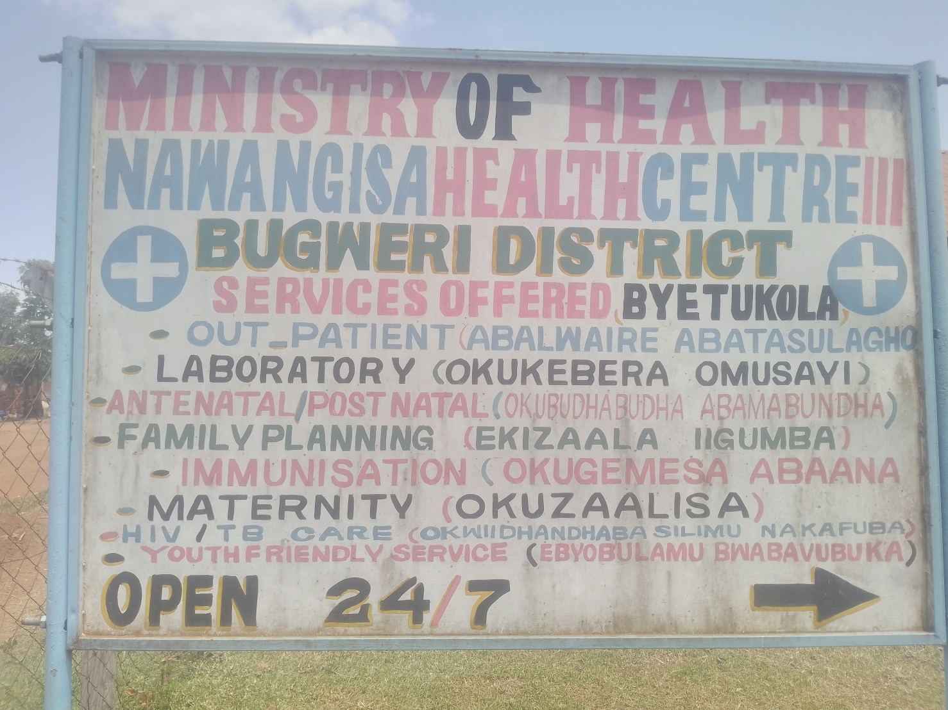
NAWANGISA HEALTH CENTRE III GATE WITH A FENCE | 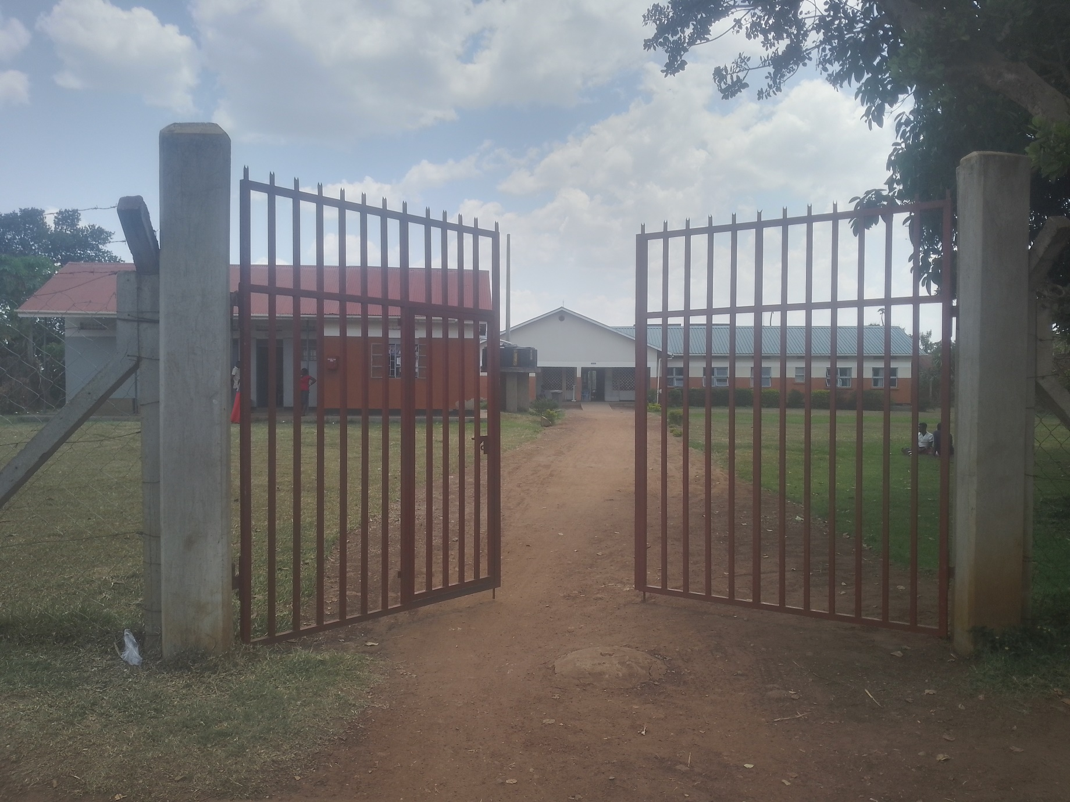

NAWANGISA HEALTH CENTRE III MAIN BLOCK | 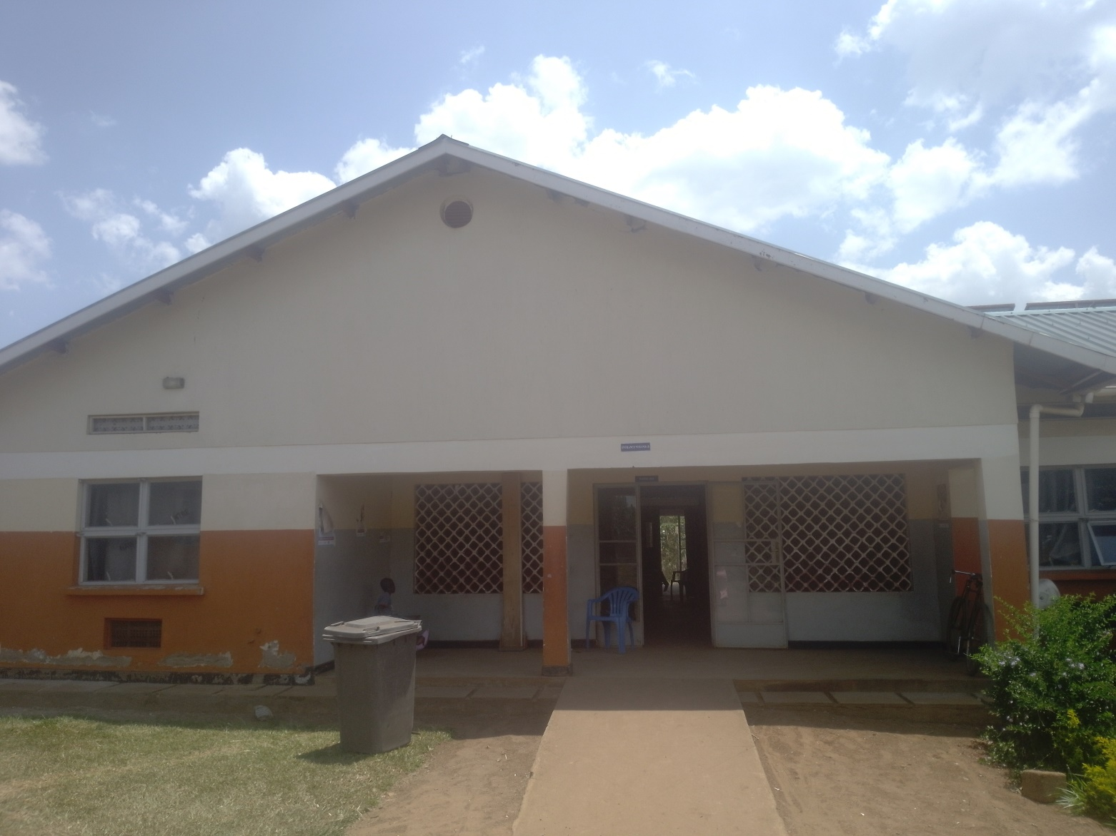
ADULT BEDS.  NOT ENGRAVED  NO IN USE | 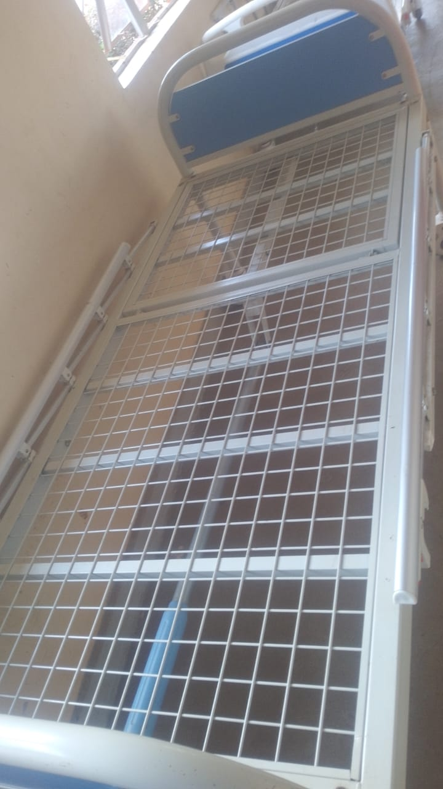
DELIVERY BED  NOT ENGRAVED  AND IN USE | 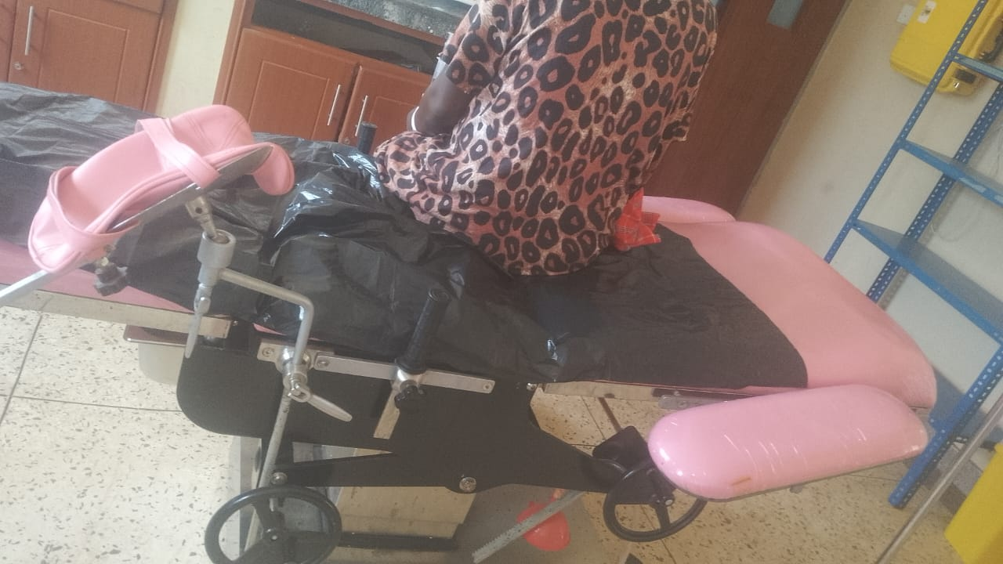
PEDIATRIC BEDS  NO TENGRAVED AND IN USE | 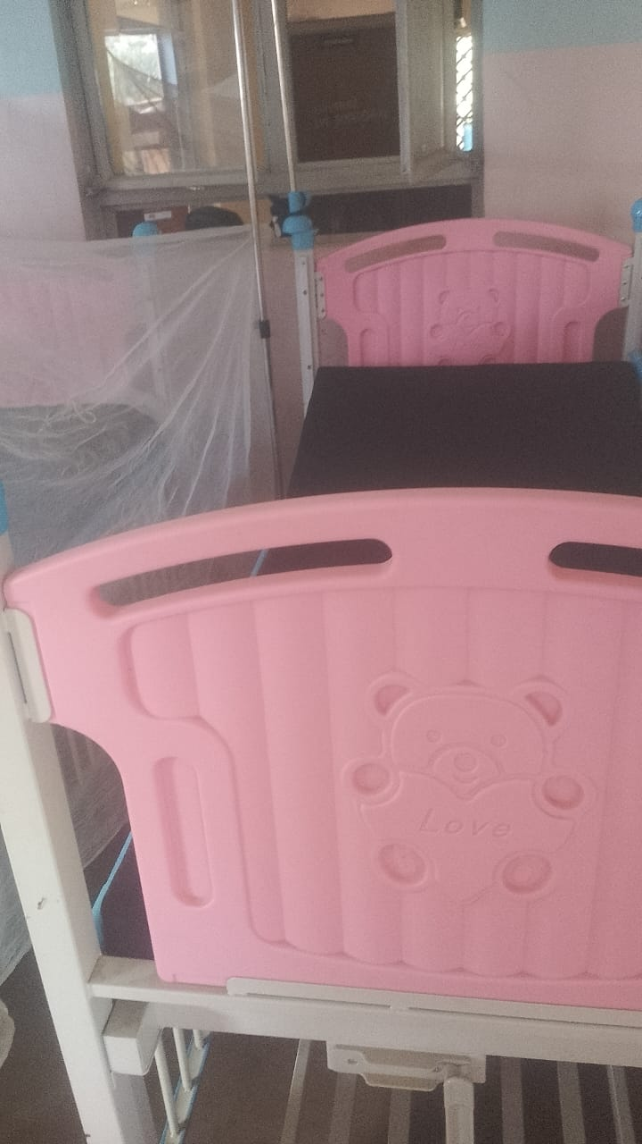
WEIGHING SCALE WITH HEIGHT METET  NOT ENGRAVED  NO TIN USE | 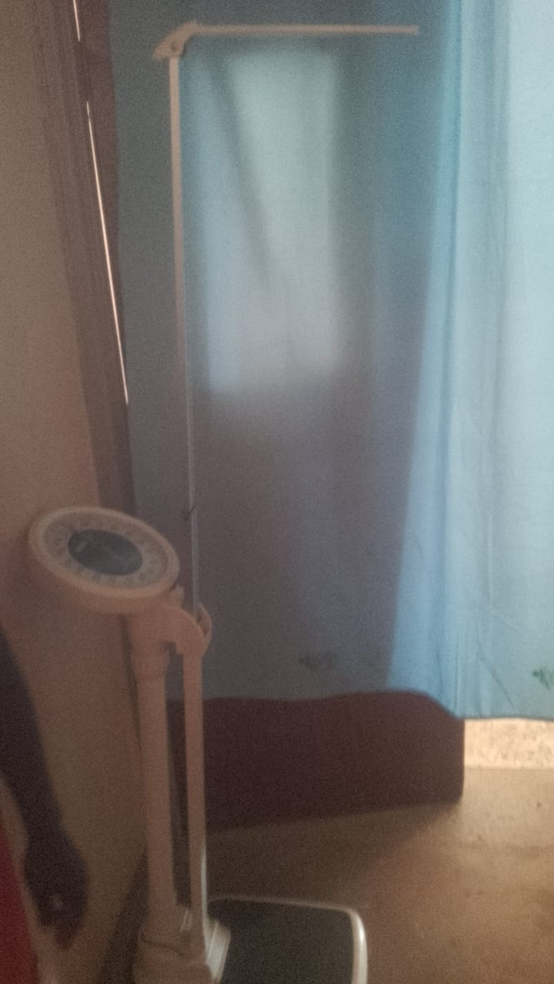
EXAMINATION LIGHT NO TIN USE | 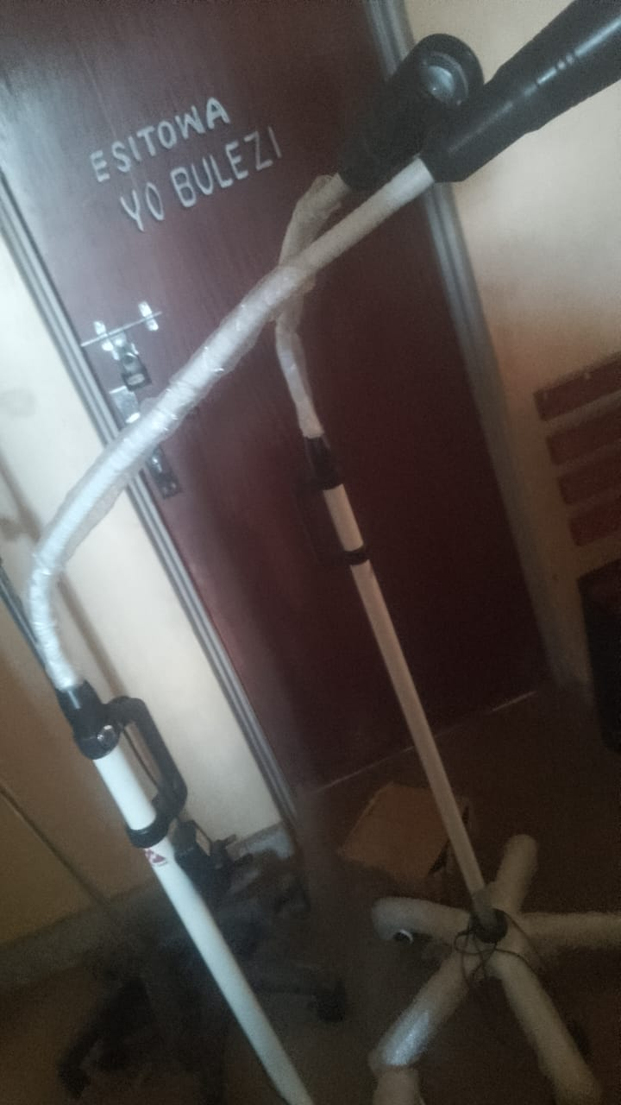
WEIGHING SCALE INFANT  NOT ENGRAVED  AND IN USE | 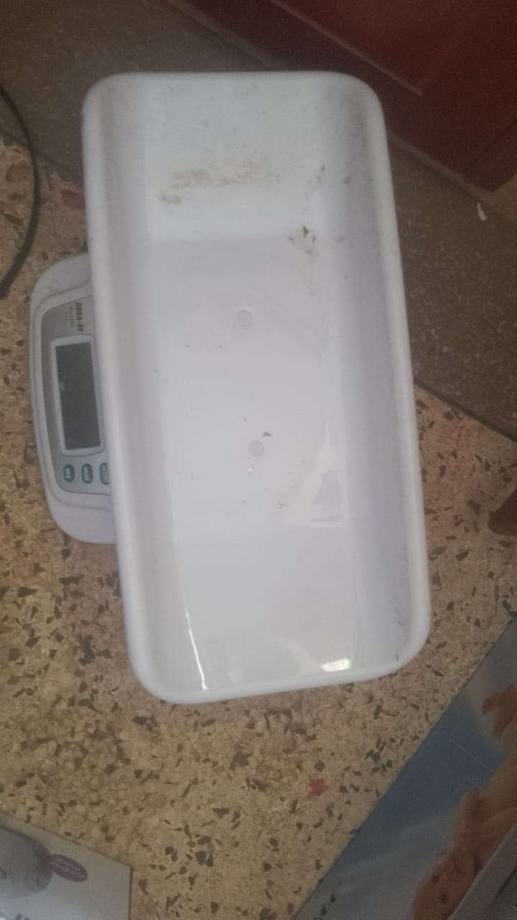
CENTRIFUGE  NOT ENGRAVED  AND ALL THE 2 ARE NOT IN USE | 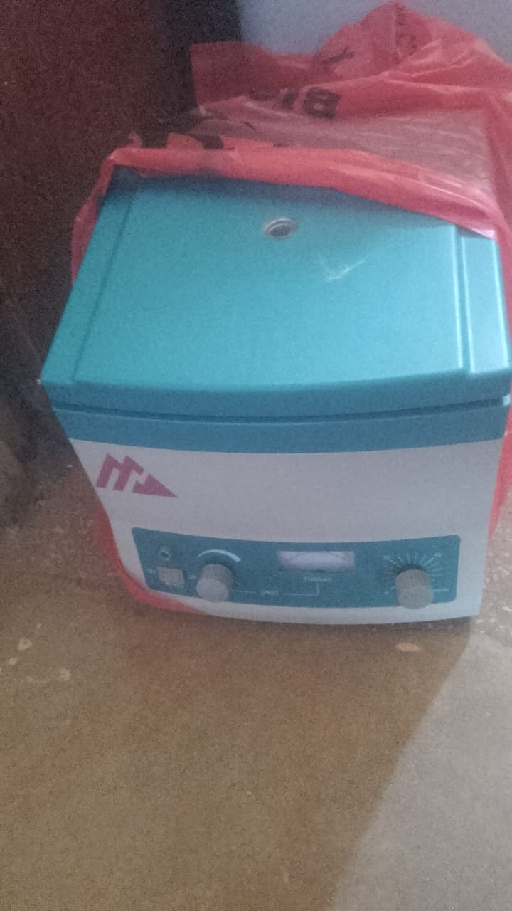
OXYGEN CONCETRATOR  NOT ENGRAVED  NOT IN USE DUE TO LACK OF POWER | 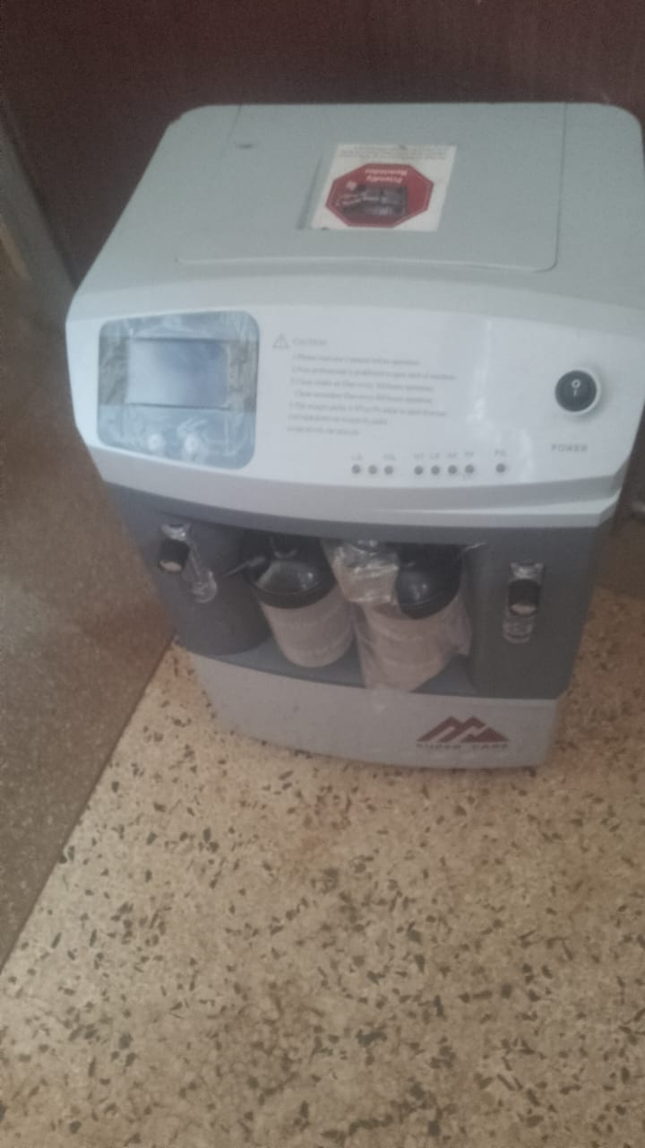
STOP WATCH  NOT ENGRAVEDNOT IN USE | 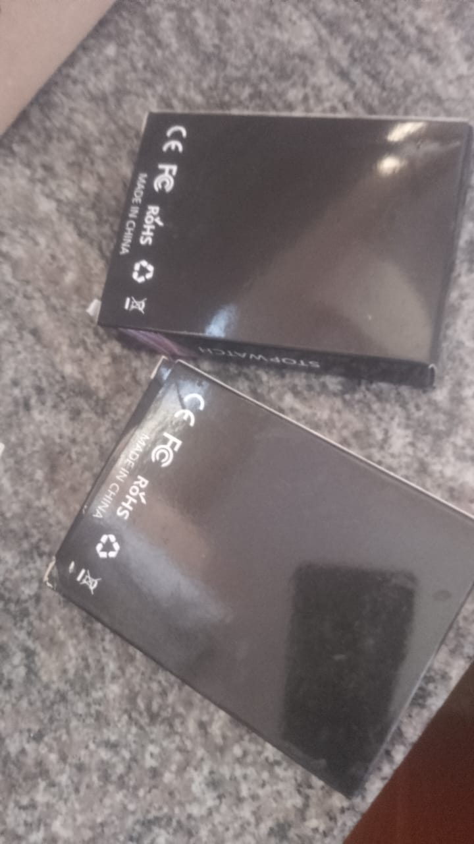
WEIGHUNG SCALE TODDLER  NOT ENGRAVED  NOT IN USE | 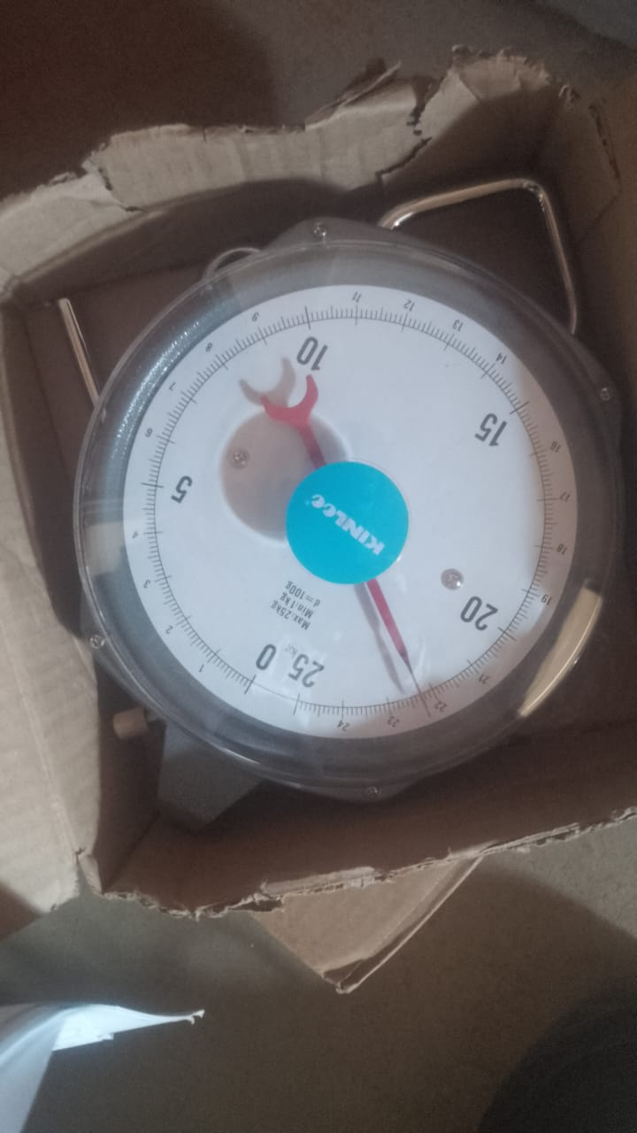
MEDICAL WASTE BINS  NOT ENGRAVED AND NOT IN USE | 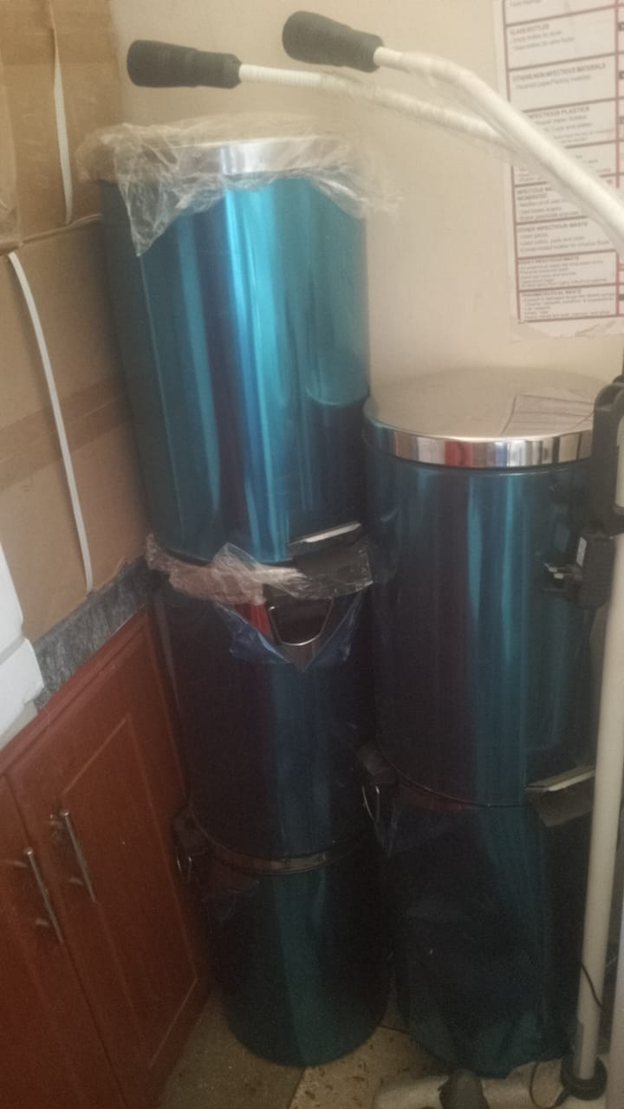

DISINFECTION BUCKETS  NOT ENGRAVED | 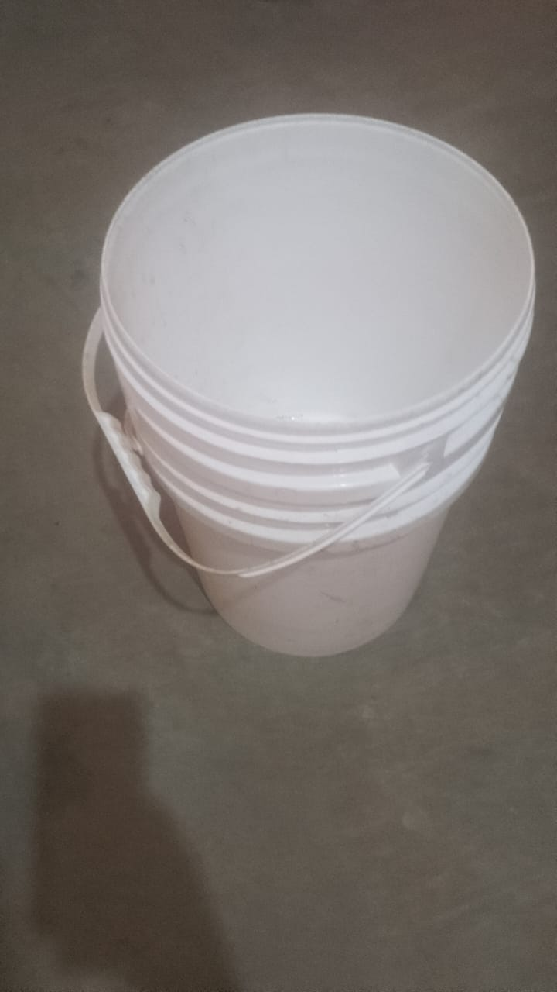
MICROSCOPE  NOT ENGRAVED | 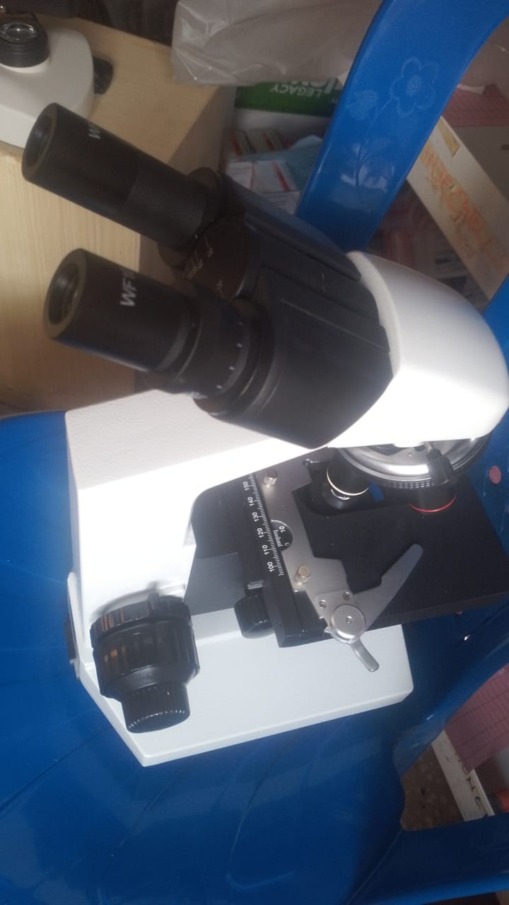
LAB STOOL  NOT ENGRAVED  IN USE | 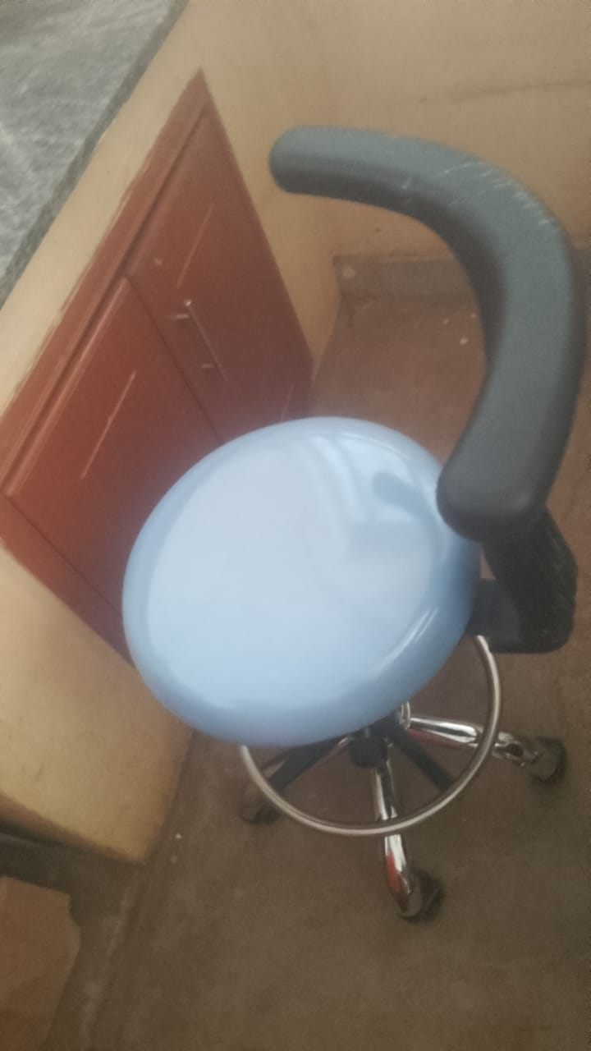
OFFICE CHAIRS  NOT ENGRAVED  ALL IN USE | 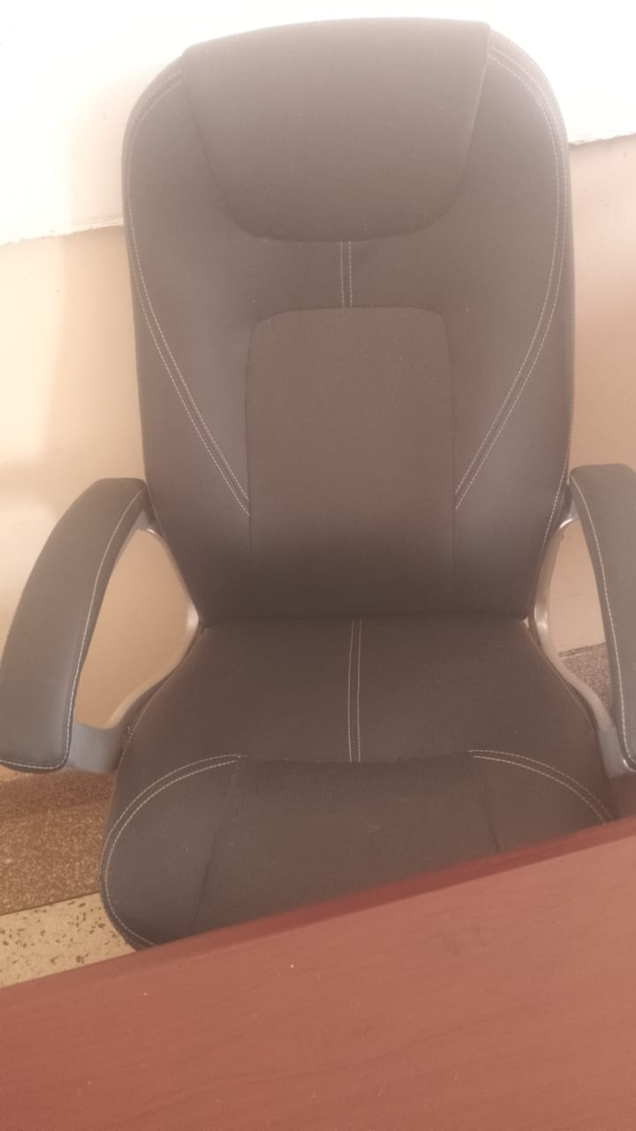
KANGAROO MOTHER CHAIR  NOT ENGRAVED | 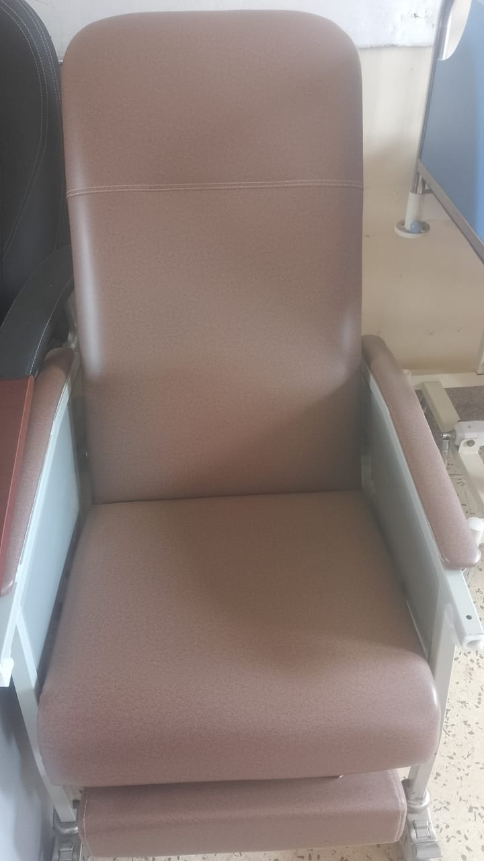
DESK  NOT ENGRAVED  AND IN USE | 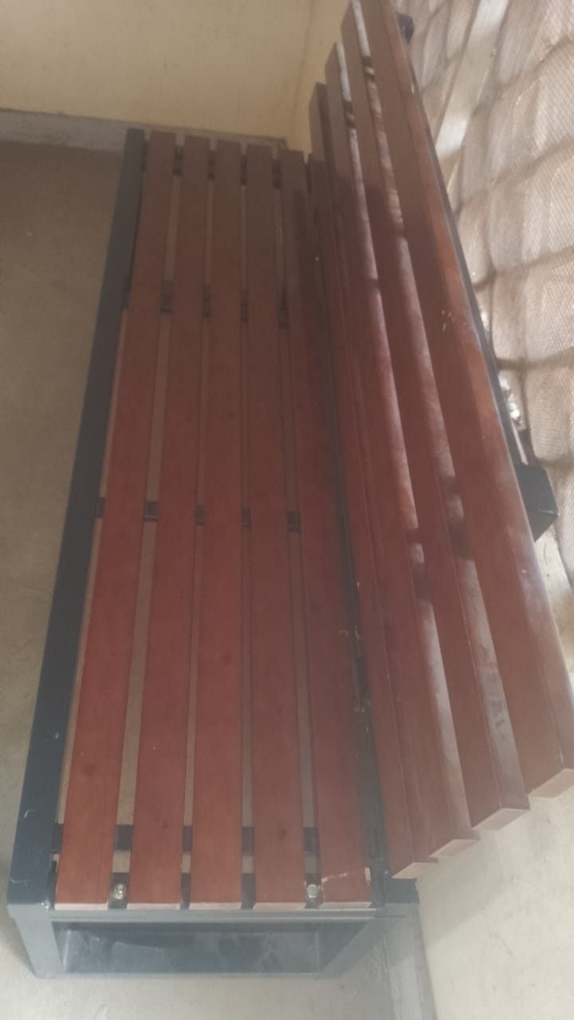
BIG TANK ON CIRCULAR CONCRETE AND A SMALL ONE RAISED ON 4 METALLIC STANDS  NOT ENGRAVED  IN USE | 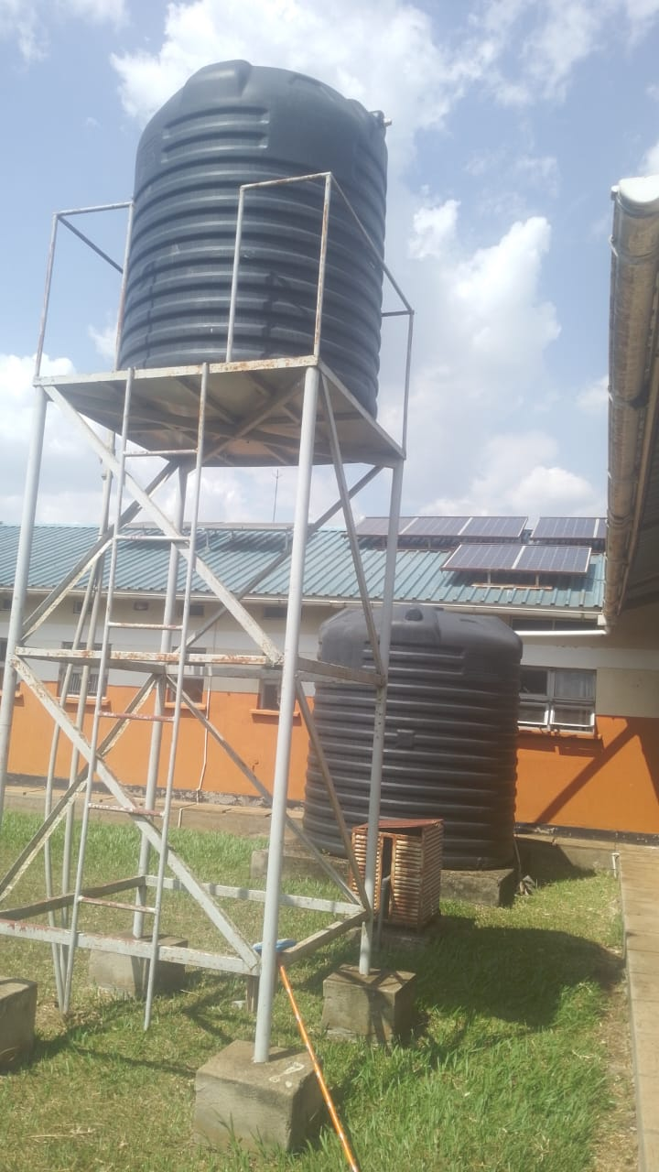
STAFF QUARTERS  1 BLOCK WITH 2 ROOMS  NOT ENGRAVED | 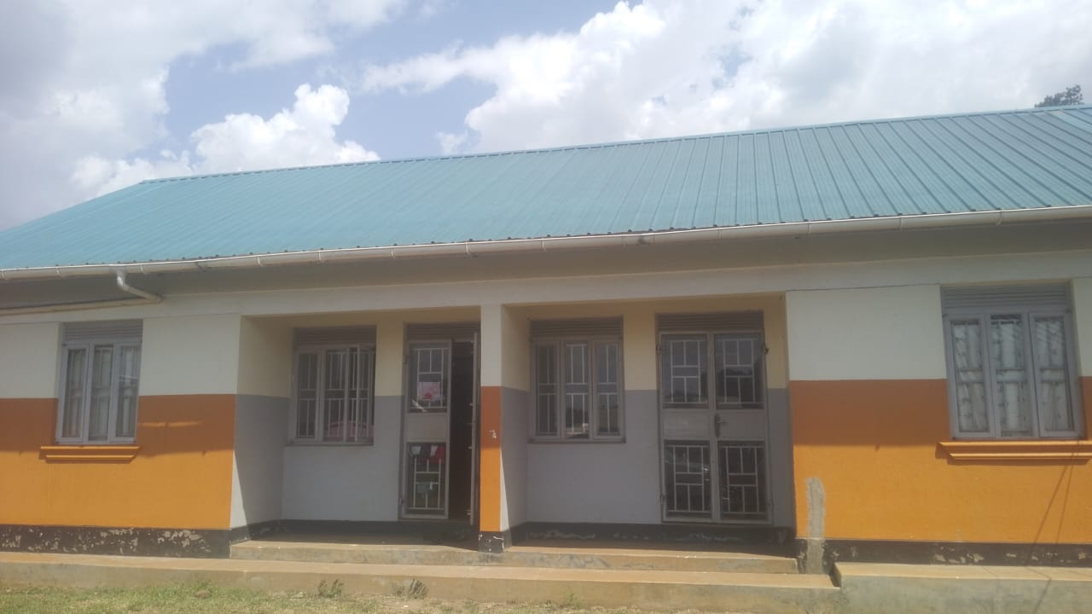
4 STANCE TOILETS  IN USE | 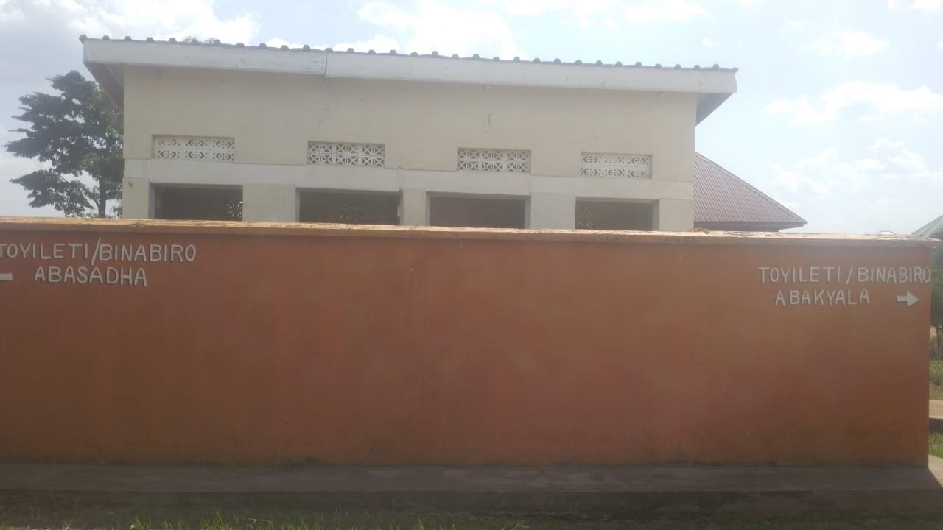
PLACENTA PIT  ENGRAVED  “PLACENTA PIT” | 